**HAPPY CANDIDATES**

**VENDOR REVIEW**

**9.1.16**

**http://www.rothrsolutions.com/happycandidate/vendoraccount/edit**

In the upper right hand corner the Vendor is able to use the pull down bar and click on these items:

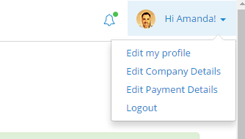

* Edit My Profile
* Edit My Company Details
* Edit My Payment Details

**EDIT MY PROFILE**

1. Vendor is not able to edit their email address – Should we allow this? Or is this something only done through admin?

**EDIT MY COMPANY DETAILS**

1. When a Vendor edits their company details will this information update on the Admin site?
2. On the Company Details page – zip code field is listed twice – please remove one.
3. We do not seem to be using the same verbiage throughout the four HC locations: Job Seeker, Owner, Admin, Vendor – for Admin, Owner and Vendor we use the term Zip and for Job Seeker we use the term Postal or Zip Code. Can we make this consistent across the board – please use Postal or Zip Code
4. On the Company Details page please add the following verbiage:

*Please update your Company Details when you have a change*

**PAYMENT DETAILS**

1. 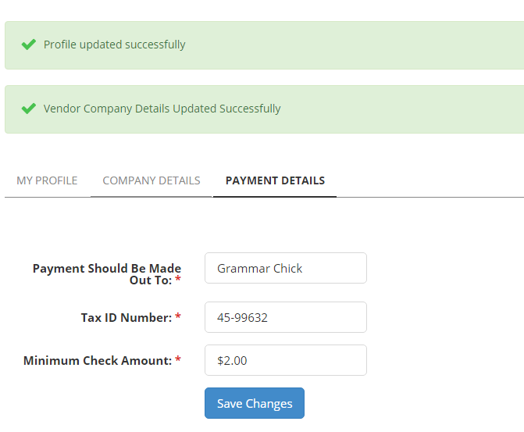On the Payment Details page there is a mandatory minimum check amount field. Please remove this. This was used in the current portal for owners only.
2. On the Payment Details page I believe we should add something that explains all payments will be made in US Dollars.

*All career portal vendor payments will be sent to you in US dollars.*

1. Payments Should Be Made Out To runs over the line can we change it to: Make Payments To

It is shorter and will fit on one line

1. Tax ID Number should be Tax ID Number or Business Number

US uses Tax ID Numbers and Canada uses Business Numbers

We can put these on two separate lines maybe if that makes more sense

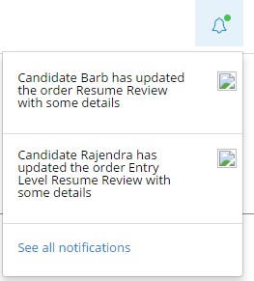**NOTIFICATIONS**

1. I really like that the vendor gets notifications when changes have been completed by a job seeker.
   1. Will the vendor employee receive these notifications on orders they have been assigned?
   2. Can we add the person’s first and last name to the notification? There might be a time when we have multiple people with the name Bob with an order.

**DASHBOARD**

[**http://www.rothrsolutions.com/happycandidate/vendoraccount/dashboard**](http://www.rothrsolutions.com/happycandidate/vendoraccount/dashboard)

I believe we discussed this already and it may be in the works. I am just unable to see it right now

1. On the Vendor Dashboard we should be able to see
   * How much is owed to the vendor for the current payment period
   * Refunds for this timeframe should be seen

**CANDIDATES**

[**http://www.rothrsolutions.com/happycandidate/vendororders/candidates/**](http://www.rothrsolutions.com/happycandidate/vendororders/candidates/)

1. I don’t understand this tab – I see a list of all job seekers who have purchased a product. This page only shows me name and email. It looks like the person’s name is a link but it doesn’t go anywhere – can you explain?

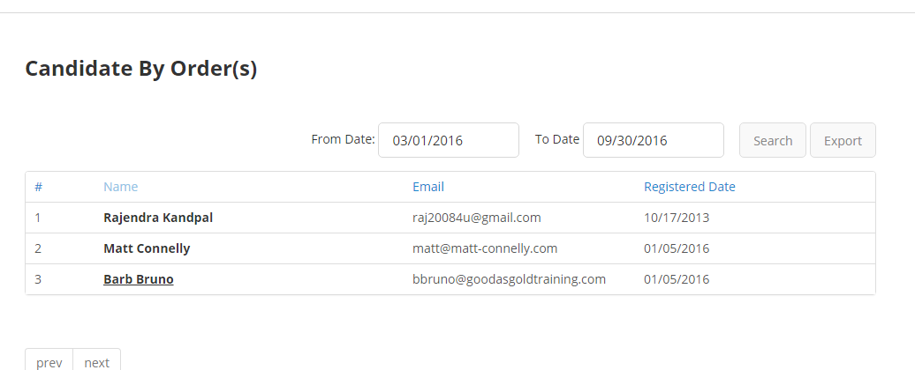

**ADD USER**

[**http://www.rothrsolutions.com/happycandidate/vendoraccount/adduser**](http://www.rothrsolutions.com/happycandidate/vendoraccount/adduser)

No issues

**MANAGE USERS**

[**http://www.rothrsolutions.com/happycandidate/vendoraccount/mgusers#str26**](http://www.rothrsolutions.com/happycandidate/vendoraccount/mgusers#str26)

1. Add a Column that has a Send Password Icon or Reset Password

**MY ORDERS**

[**http://www.rothrsolutions.com/happycandidate/vendororders**](http://www.rothrsolutions.com/happycandidate/vendororders)

When clicking on My Orders

Click on an order

Click on view

* View and Edit seem to take me to the same page
* When I close an order the Close Order Confirmation is cut off – can you make it so that we can see the whole message without scrolling

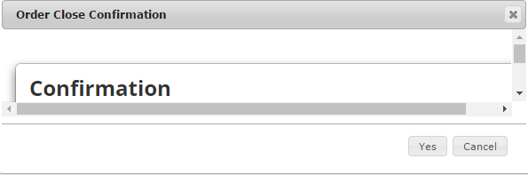

**ADD SERVICE UPDATES**

[**http://www.rothrsolutions.com/happycandidate/vendororders/addupdates/38**](http://www.rothrsolutions.com/happycandidate/vendororders/addupdates/38)

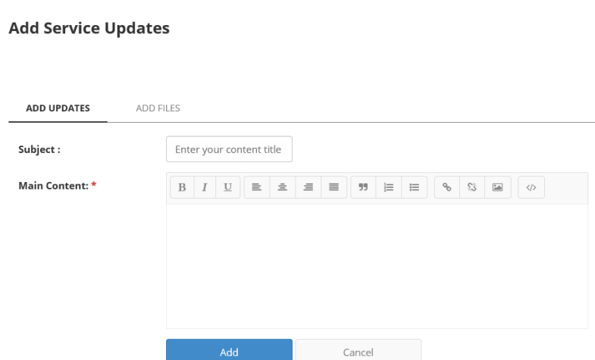

* Can we put the Add Files on the same page as Add Updates
* After typing in the Subject Field and I click the tab button the cursor moves to the Bold Symbol – it should automatically move to the open typing field.
* When you add an update it states “You have successfully updated you order”

It should say “You have successfully updated your order”

Please replace.

**User Analytics**

* The Lead Vendor will want to see what their employees have completed, pending and open
* They will want to see the assigned date and the closed date
* Perhaps even the dollar amount per Vendor User? That we can ask Barb and Matt about

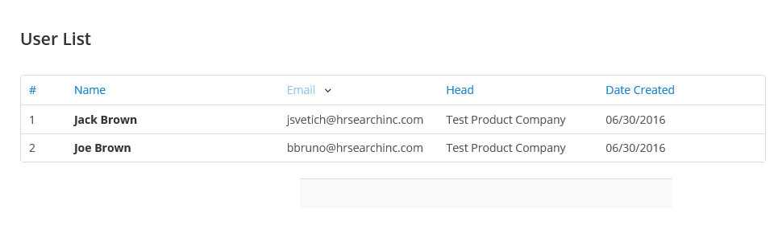

**ANALYTICS or REPORTING**

* We will need to add a Reporting or Analytics Tab
* This is what our vendors currently have and we would like to keep this type of information moving forward – I believe we have already discussed this and you may be working on something
* The Lead Vendor will need to be able to download a report and compare money for a specific timeframe to compare with their invoice each month.

